BBL7031: Types of Biosensors and their Characterization

Assignment

Discuss any commercial biosensor success story and brief history and its working principle.

---

Chinmay Garg, B16CS041

**Pregnancy Test Kits: The Tiny Strips of Hope**

The man’s quest to answer the age-old question of pregnancy is as old as the history of mankind itself. This story for the search for an answer to this eternal question is an interesting one, and yes, is naturally woven with even more interesting myths, tales, and hypothesis’.

One of the oldest known method to somewhat successfully determine pregnancy is credited to the ancient Egyptians. Though these ancient tests were based on false mythologies, they at least knew where to start looking: into the woman’s urine. They would soak various grains in a woman’s urine, and if they germinated, then voila, the test is positive. But as it turns out, this method was not very accurate. In this regard, the Egyptians were not alone. Europe was filled with such ‘piss-prophets’ during the middle ages.

The real breakthrough came when in 1928, two German scientists, Selmar Aschheim and Bernhard Zondek isolated ‘human chorionic gonadotrophin’ (hCG) from the urine of pregnant women. In the next few years alone, hCG was established as a reliable empirical marker for pregnancy testing. Urine from the human female was injected into a baby female rabbit. Then a fatal surgery was carried out to see if the rabbit ovulated, if yes, then the test was positive. This was the famous ‘rabbit test.’

This onslaught of our little furry friends didn’t stop until the advent of radioimmunoassays in the 1970s. Now the first home pregnancy test kits started appearing, but they were more of a ‘home chemistry mixing mess.’ It was only after the discovery of monoclonal antibodies and the development of enzymatic indicators that finally, in the 1990s, we were able to see the first strip based pregnancy test kits.

These contemporary strips also function by detecting the presence of hCG, a hormone produced by the placenta cells (around 6-12 days after conception). Its job is to tell the uterus not to shed the inner lining of the uterus, and to support the formation of the placenta. hCG is eliminated from the mother’s body through urine.

When a sample of this urine is applied at the end of the test stick, it is drawn up. First, it reaches the ‘reaction zone’. hCG binds with the antibodies (say AB1) present in this zone. These AB1 antibodies are attached with an enzyme having the ability to turn on dye molecules. Next comes the ‘test zone’ which has immobile antibodies (say AB2). AB2 also binds with the hCG, creating an hCG sandwich between two different antibodies. The enzymes attached to AB1 trigger a color change (Strip 1). The absence of this strip implies the absence of hCG, that is the woman is not pregnant. The last is the ‘control zone.’ Excess of AB1 (in case of pregnancy) or the whole of AB1 (otherwise) is bound here to the immobile antibodies present in this zone. The enzyme attached to AB1 again triggers a color change here. A strip must compulsorily appear here, its absence means the test is faulty. The whole process may take up to 2 minutes.

I understand that even these few minutes can feel like forever, after all, it is a pregnancy that we are talking about! But in these brief minutes, please remember that you are witnessing the fruition of a century of back-breaking scientific research. Always stop to wonder how these tiny innocent-looking plastic sticks empower you to answer the question as old as the womankind: Am I pregnant?

And the best part is that unlike the ancient Egyptians, you won’t have to wait till the next harvest.

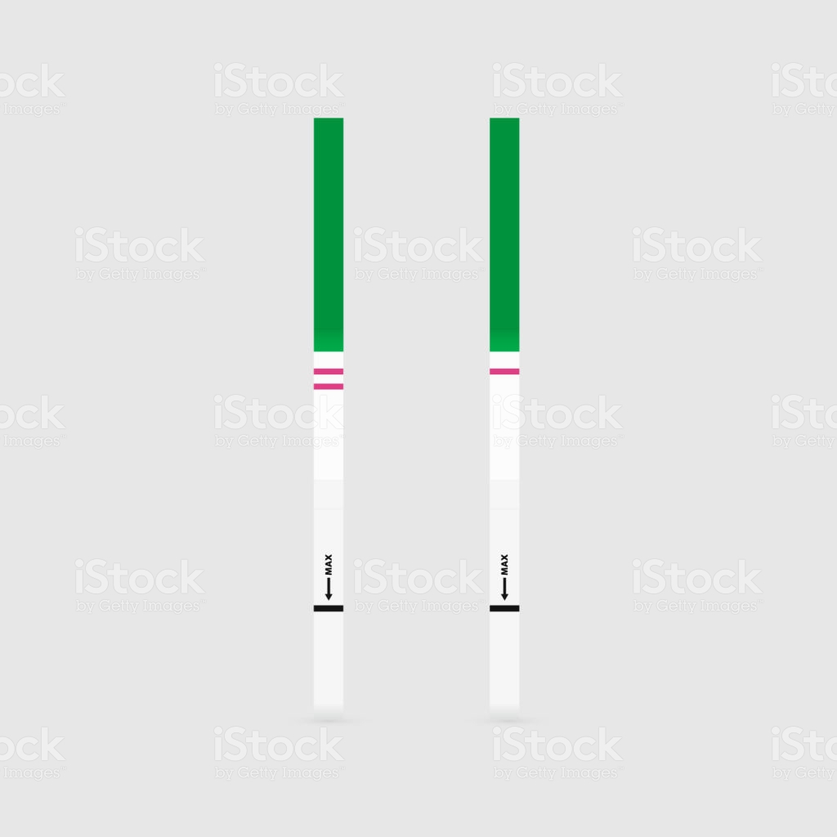

References:

https://www.youtube.com/watch?v=aOfWTscU8YM

https://en.wikipedia.org/wiki/Pregnancy_test

https://www.early-pregnancy-tests.com/history

https://www.livescience.com/37128-history-of-pregnancy-tests-ept-hcg.html

https://www.compoundchem.com/2018/11/09/pregnancy-tests/

http://sitn.hms.harvard.edu/flash/2018/pee-pregnant-history-science-urine-based-pregnancy-tests/